**KWAME NKRUMAH UNIVERSITY OF SCIENCE AND TECHNOLOGY**

**COLLEGE OF SCIENCE**

**DEPARTMENT OF COMPUTER SCIENCE**

**TOPIC: FARM MANAGEMENT SYSTEM AND MACHINE LEARNING**

**SUPERVISOR: DR. LINDA AMOAKO BANNING**

**A PROJECT WORK SUBMITTED TO THE DEPARTMENT OF COMPUTER SCIENCE, IN PARTIAL FULFILMENT OF THE REQUIREMENT FOR THE AWARD OF BACHELOR OF SCIENCE(BSc) DEGREE IN COMPUTER SCIENCE**

**BY**

**NAME: SAMUEL WILLIAMS QUAYNOR NAME: ABASS SAEED MOHAMMED**

**INDEX NUMBER: 4620518 INDEX NUMBER: 4626918**

**EMAIL: SAMWILLSQUAYE@GMAIL.COM EMAIL: SAEED.ABASS1002@GMAIL.COM**

**CONTACT: 0504638295/0248066710**  **CONTACT: 0547549272**

**CHAPTER ONE**

**INTRODUCTION**

**1.1 BACKGROUND**

From yore, agriculture has been the major source of food for humans producing the majority of the world’s food with family farming producing about 80% and the rest distributed over small farms and large-scale farms, as per the Food and Agricultural Organization of the UN.

With the exponential population increase within the last decade, there is the need to increase the productivity of agriculture in various part of the world to negate the increase demand on agricultural produce. And the best way we know how is through the integration of modern technology in traditional farming. Modern technology has contributed significantly to almost every field, from healthcare to transportation, that is to name a few. Unfortunately, this wand of technology is yet to work its magic on developing countries like Ghana, Niger, India, etc.

Hence, this farm management system seeks to integrate the power of today's technology to axe some of the outlined menaces faced by farmers using traditional farming techniques. By offering famers the ability to know the humidity, temperature, wind speed, rainfall predictions etc. in real time and also a machine learning model that will detect weeds on farmland to help farmers make informed decisions improving productivity of crop yield.

Farmers on this part of the world, especially countries like Ghana (where about 41.5% to 51.5% of the population are estimated to be farmers) rely mostly on intuition and other centuries old traditional method which have been proven to be less productive to cultivate crops. Due to factors like relying on rainfall to irrigate farmlands, wasteful heuristics methods to know the type of crops to grow on a particular soil type and farmland. This contributes to our low number of post-harvests which is estimated around an average of 20-50% every year.

The effect of climate change on farming cannot be overlooked when talking about increasing productivity in agriculture. As the atmospheric conditions keep evolving, farmers need to be aware of the changing properties of soil, unpredictable rainfalls and droughts and the type of crops to grow on these types of soil. The ignorance by farmers in the country costs a lot of losses to the farmers and revenue loss to their country. In Ghana, it is estimated that about 6.3billion USD is lost to environmental degradation which is 11% of our GDP, with water population contributing to about 3% (Srivastava, S., & Pawlowska, E.A).

Climate change as a threat to farming has also had effect on weed growth over the past decade. Some distinct transformations have been recorded in the weed flora of arable ecosystems in Europe, one research (Peters, Breitsameter, & Gerowitt, 2014). These researches show how weeds that formerly had minor effect on crops have dominance over crops now.

**1.2 PROBLEM STATEMENT**

Relative to the increase in the world’s population, productivity in agriculture(farming) also has to increase to mitigate the problems arising from increasing population.

Traditional farming methods for managing farms have proven less effective and less productive in solving food shortages and other unpredictable disasters resulting from the alarming population growth over the past decade. Although these methods in their entirety yield result, it is not enough to catch up with the pressures of increasing population on agriculture.

**1.3 AIM**

The application was created with the purpose of assisting farmers with farm management tasks, giving them access to crucial data, and connecting them with potential customers in order to help farmers use technology as a multiplier and accelerator in producing crops and resolving avoidable losses in farming.

**1.4 OBJECTIVES**

The overall goal of this project is to lower the cost of manpower and energy for farmers or users of this application while facilitating excellent crop yields by;

* Providing farmers access to live weather reports and future forecasts.
* Helping farmers detect weeds affecting their crops using computer vision.
* Connecting farmers to potential customers.
* Provide farm management system to farmers keep track of their farming activities.

**1.5 PROJECT SCOPE**

Small-scale farmers were the focus of this project, although provisions have been made for continued expansion to satisfy the needs of commercial large-scale farms.

**1.6 PROJECT MOTIVATION**

Given that family farms and small-scale farmers generate more than 80% of the world's food and that more than 70% of these farmers lack access to modern technologies, we should figure out a means to help them enhance crop production. By accomplishing this, we assist farmers in lowering labor expenses and implementing cutting-edge business strategies that have been shown to increase crop yields. We intend to free the farmer from time-consuming effort and dependence on outmoded farming practices that don't substantially improve crop cultivation by developing a smartphone application to assist farming tasks. We hope that by implementing this strategy, we can make the work of farmers and users of this application easier and, in the long run, reap larger rewards in terms of productivity and finances.

**1.7 PROJECT BENEFICIARIES**

DigiFarm was made for agricultural institutes concentrating on farming activities, as well as farmers operating on various small scales of business.

**CHAPTER TWO**

**LITERATURE REVIEW**

**2.1 INTRODUCTION**

Different literatures were researched from both the theoretical and experiential sides from many internet sites relevant to the implementation of such initiatives. This system keeps crop production rates at an ideal level. Farm management systems also minimize labor, time consumption, and increase farming convenience; hence, critically assessing existing systems is vital to the creation of this current system. This chapter examines comparable projects and considers their benefits and drawbacks.

**2.2 FARMIO**

Farmio is an AgriTech startup that develops smart solutions for greenhouse and indoor farmers by combining IoT, Cloud, and Machine Learning technologies with modern farming methods to increase agricultural yield, resource efficiency, sustainability, feasibility, food safety, and food quality.

**2.2.1 FEATURES**

* Control farm activities remotely
* Measures temperature, humidity, pH level

**2.2.2 LIMITATIONS**

* No weed, pest or disease control feature
* No irrigation system
* Not free

**2.3 FARM DECK**

It is a full IoT based farm management app that uses sensors to record farm data.

**2.3.1 FEATURES**

* Livestock tracking and identification
* Rainfall monitoring
* Soil moisture, temperature and humidity
* Water quality
* Task manager

**2.3.2 LIMITATIONS**

* Limited to only Australians
* Not free
* No weed, pest or disease control feature
* Uses only IoT without any machine learning models for predictions

**2.4 AgrIOT**

AgrIOT is a geo-spatial agriculture data management platform to collect and analyze large-scale fruit tree data reliably, timely and efficiently, using mobile apps and wireless sensor networks. AgrIOT supports farmers, Agri-Service providers and government institutions to increase productivity, reduce losses due to pest and optimize water use efficiency.

**2.4.1 FEATURES**

* Smart irrigation system
* Weather sensing or data recording
* Soil moisture sensing
* Other networking services

**2.4.2 LIMITATIONS**

* Services are priced and expensive
* No free dedicated app for farmers to manage farm on their own
* Not available in all countries

**2.5 eKonomics**

eKonomics offers a nutrient management app that enables customized agronomic advice for optimum nutrient management, growing degree days, and local rainfall.

**2.5.1 FEATURES**

* The Rainfall Tracker tool tracks current and historical precipitation at the field level
* The Nutrient Removal Calculator estimates crop nutrient removal of nitrogen, phosphorus, and potassium for a broad list of field crops
* Approximate date the crop will reach maturity

**2.5.2 LIMITATIONS**

* No weed, pest or disease control feature
* No soil examination for type and suitable crops to grow

**CHAPTER THREE**

**METHODLOGY**

**3.1 INTRODUCTION**

This chapter describes how the DigiFarm application will be developed. It will bring everything into perspective with the approach used, the explanation for its selection, and the benefits. The system overview will be explained together with the development tools utilized.

**3.2 DEVELOPMENT METHODOLOGY**

This system will be implemented using the Incremental model. The reason for this approach is due to user exposure and evolving it through numerous phases till the whole system is developed. This strategy interweaves project specifications, development, and system validation to provide timely feedback upon delivery. The system's ability to interface with the user will also be created gradually. Because this model of development allows for better testing and debugging, it will be the most effective and efficient for this reason.

**3.2.1 ADVANTAGES OF INCREMENTAL METHODOLOGY**

1. Generates working software quickly and early during the software life cycle.
2. This model is more flexible – less costly to change scope and requirements.
3. It is easier to test and debug during a smaller iteration.
4. Easier to manage risk because risky pieces are identified and handled during it’d iteration.

**3.3 REQUIREMENTS CAPTURE AND SPECIFICATION**

Early in a project's lifecycle, requirements capture is a research process used to define and qualify the project's scope. The purpose of the study is to identify users' common needs and expectations as well as their opinion on the product. When projects lack focus or the project scope has to be evaluated, the requirements capture is helpful. When a project has been developed only to meet a business need, the study offers an unbiased user perspective. In order to guarantee that the project is successful, the requirements capture results are then utilized to strike a balance between the organizational objectives and the user needs.

This is the process of determining what the application should and should not do. In other terms, it is the process of finding and specifying the software's functionality.

The requirements specification is a tool for imposing limits on the application development process. This way, the developers do not waste time adding needless functionality to the program and do not produce an application that does not fully fulfill the demands of the consumers. The requirements specification can be used as a guideline to evaluate the project's success or failure once it is completed. Interviews were the primary means of gathering requirements for this project.

It entails four steps;

* Feasibility Study
* Requirement Gathering
* Software requirement specification
* Software requirement Validation

**3.4 FUNCTIONAL REQUIREMENTS OF THE APPLICATION**

The function or components of a software system are described in the functional requirements. An explanation of a function includes a list of inputs, the behaviors they produce as outputs, and how the system may adapt to a changing environment. It provides a detailed description of the functions and services the system should offer. The following things determine this:

* Type of software
* Expected User(s)
* Computer system that runs software

**This system operates in several stages:**

1. The program will ask for permission to access the user's device location and display current and/or upcoming weather forecasts from the OpenWeatherMap API.
2. To manage the operations on their farms, users are permitted to build virtual replicas of their farms in the application.
3. The application gives users information about the different crops they might want to grow, including the germination period, cultivation period, and beneficial cultivation practices.
4. The program includes an e-commerce component to help farmers reach out to potential clients.
5. A news component is also included in the application to keep farmers informed of events in their area.
6. Additionally, the program includes machine learning algorithms to help farmers make decisions and implement cutting-edge farming techniques.
7. The security component of the application will ensure user privacy by allowing users to change their passwords to protect their personal information.

**3.5 UML MODELS**

**3.5.1 USE CASE DIAGRAM**

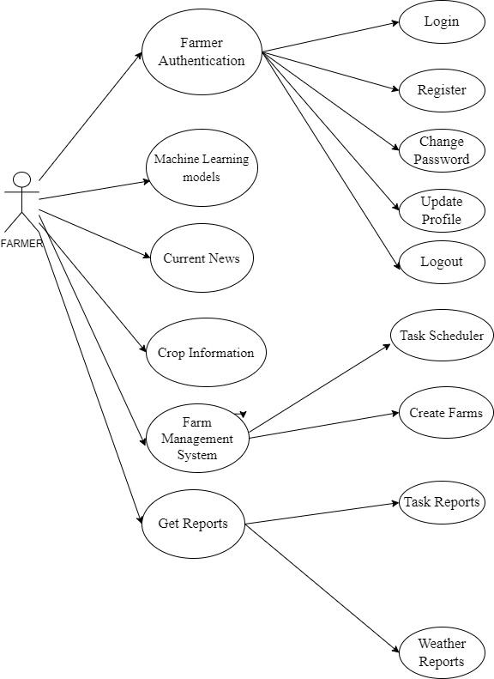

**3.5.2 ACTIVITY DIAGRAMS**

**3.5.2.1 FARMER AUTHENTICATION – Register**

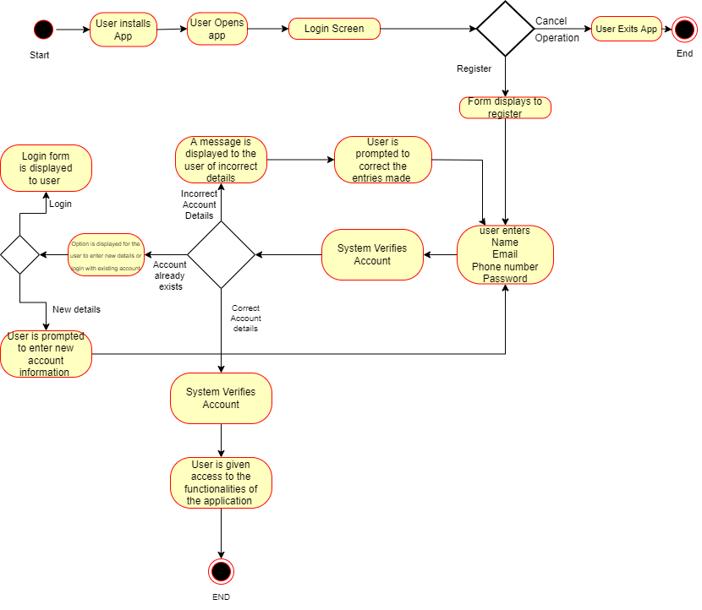

**3.5.2.2 FARMER AUTHENTICATION – Login**

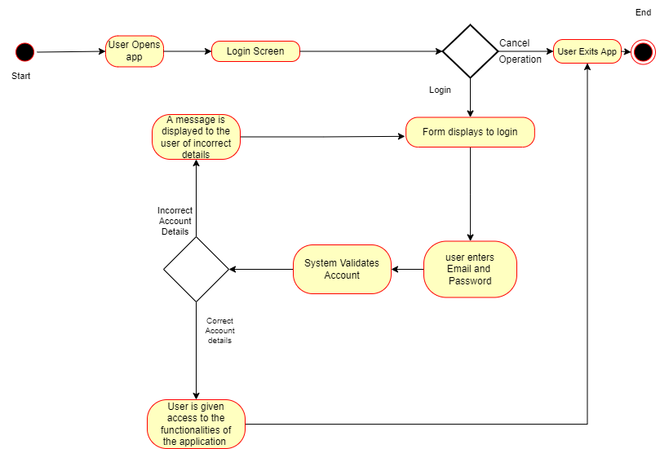

**3.5.2.3** **FARMER AUTHENTICATION – UPDATE PROFILE**

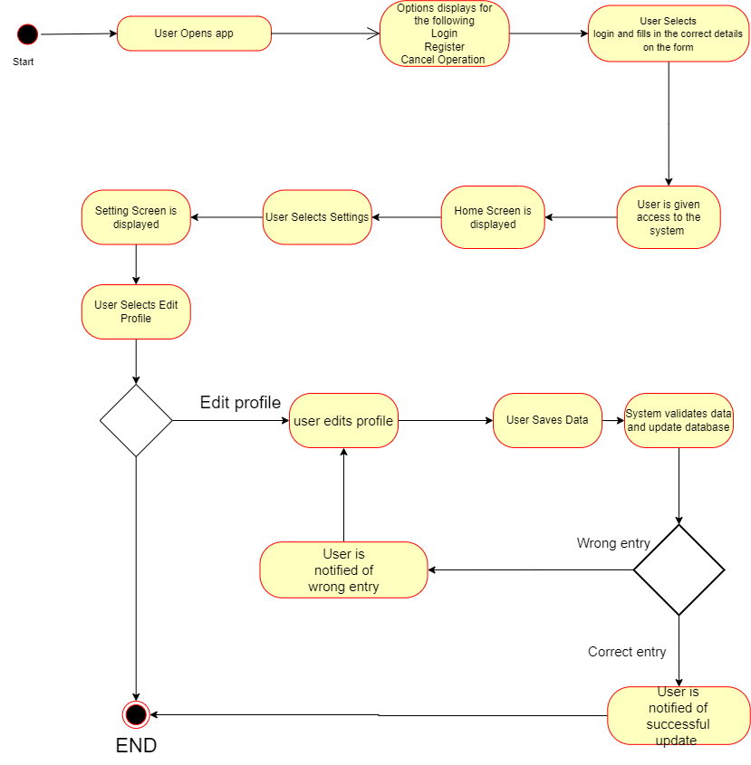

**3.5.2.4 FARMER AUTHENTICATION – CHANGE PASSWORD**

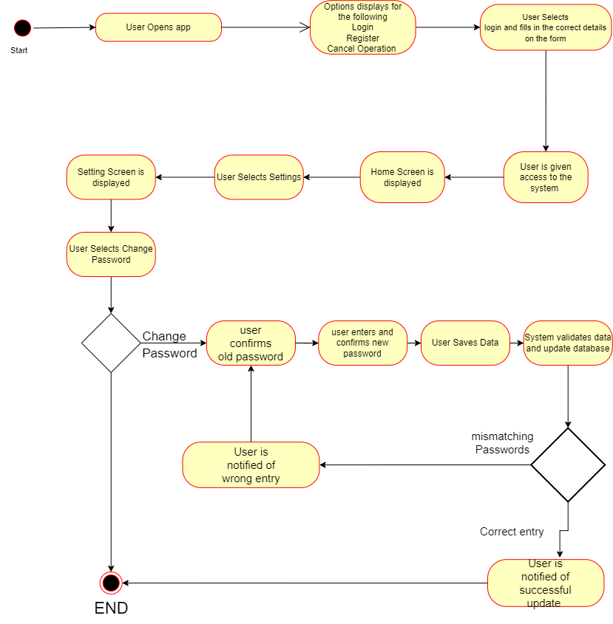

**3.5.2.6 CROP INFORMATION**

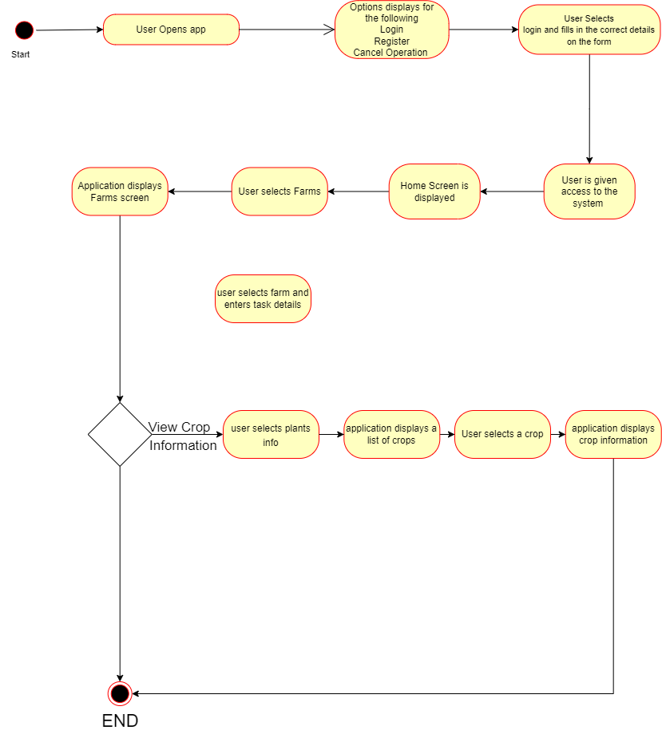

**3.5.2.7 FARM MANAGEMENT SYSTEM – CREATE FARM**

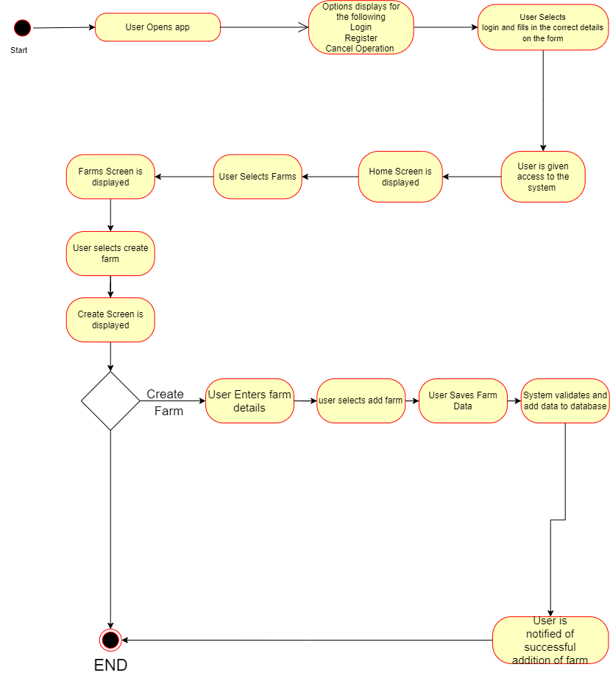

**3.5.2.8 FARM MANAGEMENT SYSTEM – SCHEDULE TASK**

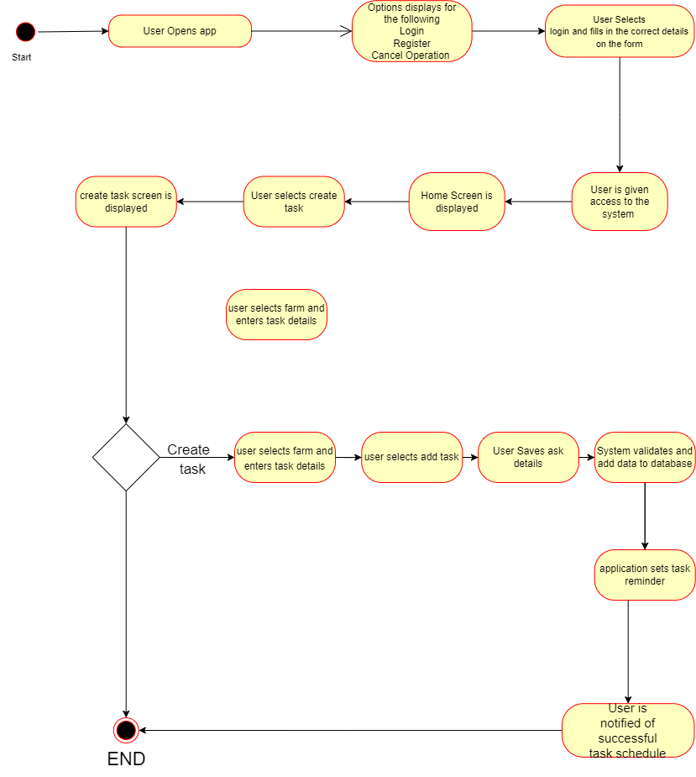

**3.5.2.9 CURRENT NEWS**

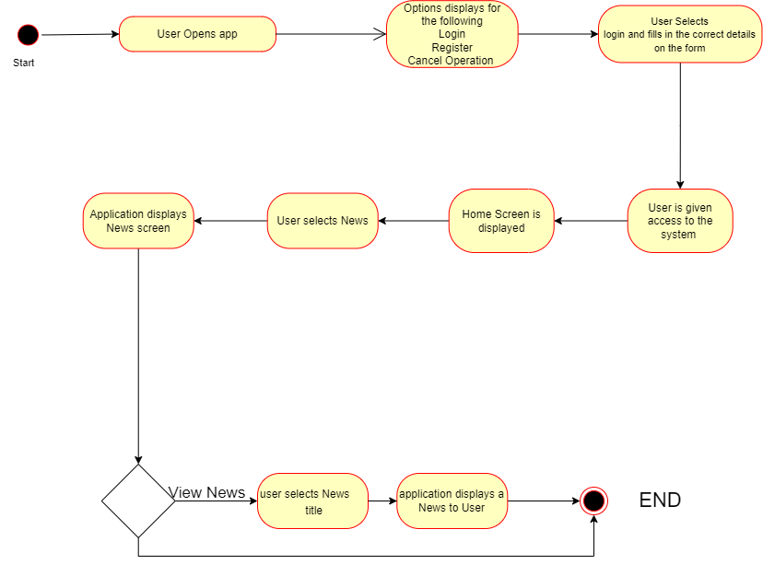

**3.6** **DATABASE STRUCTURE OF THE APPLICATION**

The application makes use of Google Firebase, a Realtime Database in which data is stored as JSON objects. It is similar to a JSON tree stored in the cloud. There are no tables or records in this database, as opposed to a SQL database. When data is added to the JSON tree, it becomes a node with an associated key in the existing JSON structure.

**CHAPTER FOUR**

**IMPLENTATION AND DESIGN**

**4.1 INTRODUCTION**

The process of ensuring that the information system is operational is known as implementation. It entails either building a new system from scratch or building a new system from an existing one. It enables users to take control of its operation for use and evaluation. It entails instructing users how to use the system and planning for a smooth transition.

After the proposed system is built, it must be implemented to solve a problem identified in the existing system; this is the process of converting a system specification into an executable system. It entails the process of software design and programming.

**4.2 DEVELOPMENT**

The following development tools were used to create the proposed system:

**4.2.1 VISUAL STUDIO CODE**

Visual Studio Code, commonly known as VS Code, is a source-code editor developed by Microsoft using the Electron Framework for Windows, Linux, and macOS. Among its features are debugging assistance, syntax highlighting, intelligent code completion, snippets, code refactoring, and embedded Git. Users can install extensions that add new features.

**4.2.2 FLUTTER**

Google's Flutter is an open-source UI software development kit. It is used to create cross-platform applications from a single codebase for Android, iOS, Linux, macOS, Windows, Google Fuchsia, and the web.

**4.2.3 GOOGLE FIREBASE**

Firebase is a collection of application hosting services. It provides NoSQL and real-time database, content, social authentication, and notification hosting, as well as services such as a real-time communication server.

**4.2.4 RAPIDAPI**

RapidAPI gives programmers access to over 30,000 APIs for use in a variety of platforms, allowing them to bring services and information to new audiences and contexts that may be adjusted to enable personalized user experiences.

**4.2.5 JUPYTER NOTEBOOK**

Project Jupyter is a project with goals to develop open-source software, open standards, and services for interactive computing across multiple programming languages.

**4.2.6 FLASK**

Flask is a Python-based micro web framework. It is characterized as a microframework because it does not necessitate the usage of any specific tools or libraries. It lacks a database abstraction layer, form validation, and other components where third-party libraries provide common functionalities.

**4.3 SCREENSHOTS OF THE WORK**

**4.4 TESTING**

Testing is frequently a key part of the software development process. It determines if the system produces the correct result when given specific inputs. It allows the developer to identify faults and assess whether or not the requirements have been met.

**4.4.1 COMPONENT TESTING**

Before integrating the system, each individual module was tested independently to find and fix faults.

**4.4.2 APPLICATION TESTING**

After integrating all of the application’s modules, the entire application was tested with real-world data to determine whether the modules could work together as expected.

**4.4.3 TEST PLAN**

The test plan's objective is to guarantee that the application has been thoroughly tested and certified. The test plan takes into account the application's functional needs. This test strategy is essential for ensuring that all criteria are still satisfied once modifications are implemented. The testing was carried out with two key objectives in mind:

* To confirm that the application's source code is error-free and effective.
* To ensure that all user needs are met by the software designed.

**4.4.4 VERIFICATION**

The system was tested to see if there would be any logical flaws or unintended outputs if the user entered specific information. These unexpected outcomes could be the consequence of the user formatting the output and accidentally feeding some data into the wrong area. The end-user might then be informed of each of these failures with the proper notifications.

**4.4.5 VERIFICATION PLAN**

The verification was performed as follows:

* Act and think like a regular software user.
* Try doing everything wrong and see what happens.
* Take note of the software's responses.
* Make suggestions to correct the errors.

The outputs must be discovered to satisfy the user's needs and should be in the format that the user desires.

**4.4.6 VALIDATION**

The built application was validated to make sure that it complies with all of the necessary needs of the user.

**CHAPTER FIVE**

**CONCLUSION**

**5.1 INTRODUCTION**

In this chapter, we will draw conclusions about the project and offer suggestions for improving the proposed system. We will also go over the several restrictions we ran into while designing and putting this project into practice, as well as how the system might be enhanced in future designs.

**5.2 ACHIEVEMENT**

Individually constructed working prototypes of the various components show that the software development process achieved the design goals outlined in the various chapters. These were compiles into an android app and tested on a variety of our mobile devices, to ensure they operated efficiently and seamlessly, the following are just a few of the many successes:

* Farmers can make judgments about their farmland based on the knowledge of the meteorological conditions provided by the application.
* A notification system was created, in order to inform the farmer or user of their scheduled agricultural operations.
* Agricultural information has been made available to give farmers a one-stop shop for conducting crop research.

**5.3 DRAWBACKS**

The following are the main difficulties encountered in the development of this project:

* The accessibility of agricultural data is one of the main issues. It is well known that agricultural field trials are time consuming, expensive, and that the arrangements made to gather information from farmers are insufficient.
* Obtaining agricultural data from private cooperatives proved to be expensive as a result of the decline in the value of our currency relative to the US dollar.
* Due to the high cost of the APIs used to offer some of the information in the application, low-cost subscriptions were the only way to provide a limited amount of information.

**5.4 RECOMMENDATIONS**

With the right funding, this application can be developed to address the needs of both small and large-scale farms. Hardware can also be created in conjunction with the application to help farmers further cut back on the number of workers they need on their farms, which will lower costs and increase convenience. The application's e-commerce component can be developed to link farmers not only to consumers but also to suppliers of high-quality agricultural seeds and contemporary farming equipment.

**5.5 CONCLUSION**

This project introduces the use of weather APIs to give farmers with reliable weather information and a farm management system to aid in the planning of farming activities. With machine learning algorithms, it will support farmers in making decisions. It will function as a central hub for crop research for farmers.

**5.6 REFERENCES**

Varghese, R., & Sharma, S. (2018). Affordable Smart Farming Using IoT and Machine Learning. Second International Conference on Intelligent Computing and Control Systems (ICICCS), 645-650, <https://doi.org/10.1109/iccons.2018.8663044>

Peters, K., Breitsameter, L. & Gerowitt, B. (2014). Impact of climate change on weeds in agriculture: a review. *Agron. Sustain. Dev.* **34,**707–721. <https://doi.org/10.1007/s13593-014-0245-2>

Srivastava, S., & Pawlowska, E.A. (2020, September 26). Ghana: Balancing economic growth and depletion resources

https://blogs.worldbank.org/africacan/ghana-balancing-economic-growth-and-depletion-resources